Children’s Justice Act Task Force (CJATF)
Monday, October 5, 2026 | 12:00–1:00 PM
Act 108
In Attendance:
Matthew Bernstein, Office of the Child Youth and Family Advocate
Britaney Watson, The Root Social Justice Center
Kelli O’Neill, Clinical Social Worker
Stefanie Comstock, Spectrum Youth Services
Gary Marvel, Department of Corrections
Tracey Wagner, UVM Health & VT SANE Board
Hannah Marble, Department for Children and Families
Jen Harris, Department for Children and Families
Nancy Miller, Department for Children and Families
Lindsay Barron, Department for Children and Families
Jenn Poehlmann, Center for Crime Victim Services
Tracy Patnoe, Child Advocacy Center Representative
Dr. James Metz, UVM Health
Zoe Nixon, Vermont Children’s Alliance
Trisha Black, Child Advocacy Center Representative
Kate Bailey, Voices for Vermont’s Children
Sam Prince, Vermont Children’s Alliance
Patti Randall, Vermont Children’s Alliance
Michelle West, Department for Children and Families
Tory Emery, Dartmouth Health
Kristin Gozzi, Deputy State’s Attorney
Courtney O’Brien, Agency of Education
Rob Post, Vermont Judiciary
Kerrie Johnson, Office of the Defender General, Juvenile Division
Arial Beaulac, Kingdom Recovery Center
Justin Pinard, Vermont School Counselors
Housekeeping Items:
This is the time of year that CJA is coordinating the annual presentations from CJA grant recipients, including the Vermont Children’s Alliance, the UVM Child Safe Program, and the Vermont Guardians Ad Litem. Presentations are typically 20 minutes long and provide an opportunity for task force members to hear how CJA dollars are being spent.

Act 108:
- CJA is being used to gather stakeholder input on Act 108, and the invited group is being consulted with as an advisory group. The deadline for the interim Act 108 presentation is April 1, 2027. The final report will be due to the committees on October 1, 2027.
- Act 108 Website: https://dcf.vermont.gov/contacts/boards/child-abuse-working-group
- Discussion occurred surrounding the new mandated reporter training, reporting in general including the harms, and Title IV:
  - Overall, participants reported that the training continues to create confusion for mandated reporters, particularly around when a report should be made, what types of reports are accepted, and what happens after a report is submitted. Participants appreciated the training’s emphasis on community resources available to support families.
  - Concerns were raised that the training may lead reporters to feel responsible for conducting “mini investigations” or determining what services a family needs. Educators similarly reported that, while they understand their statutory obligation to report, they remain unclear about when they should and should not make a report.
  - Participants also expressed concern about the training’s discussion of potential follow-up by CIES, including requests for additional questions, information, or police affidavits. There was confusion about whether mandated reporters would be expected to complete these tasks and concern that such responsibilities may more appropriately fall to law enforcement or CIES. One participant also raised concerns that asking mandated reporters to conduct follow-up questioning of victims or witnesses could create evidentiary or prosecution issues by potentially placing reporters in the role of “state actors.”
  - Additional discussion focused on language suggesting that reporters may help determine what a family needs or identify who should be consulted. Participants questioned whether making these determinations should be the responsibility of the mandated reporter.
  - Additional discussion focused on the potential impact of asking mandated reporters to gather additional information from children. Participants raised concerns that repeated or detailed questioning by individuals who are not trained to conduct abuse interviews can be traumatizing for children. There was also concern that asking mandated reporters to “dig deeper” into what a child has disclosed may be inconsistent with the concept of avoiding interference with the investigative process. Participants noted that mandated reporters should generally gather the basic facts necessary to make a report rather than conduct additional questioning.
  - The group also discussed the potential harms associated with reporting. Participants emphasized that reporting is not benign and that inaccurate or unnecessary reports can cause harm to children and families. There was discussion about whether the system could have a mechanism to reconsider or “reset” when a report is made in error. Medical providers were discussed as one example, with participants noting that reports made by medical professionals may carry significant weight even when the underlying information may be subject to interpretation. Participants described efforts in medical settings to move providers away from reflexive reporting and toward making informed reports, emphasizing that the mandate to report also carries a responsibility to make a quality report. At the same time, the group recognized the need to avoid setting the threshold for reporting too high and stressed the importance of having well-trained and effective screeners. Participants also noted that medical providers should be prepared to provide medical records supporting a report when appropriate.
  - Participants discussed differences in reporting rates across Vermont. While there may be areas where reporting occurs at a high rate, participants noted that other areas continue to experience significant underreporting, indicating a continued need for training. The group also discussed the fact that children who disclose information do not always want the matter investigated.
  - Concerns were raised about declining case numbers in some areas. Participants questioned whether factors such as wait times and delays in receiving callbacks may be contributing to declines in reporting. There was concern that reductions in case numbers may not necessarily reflect a corresponding decrease in abuse occurring in the community and could instead indicate that people are not reporting. Participants emphasized the importance of examining reporting trends and continuing to strengthen community education and training.
  - The group also discussed circumstances in which a victim does not want an investigation to proceed, particularly in peer-to-peer cases. Participants noted that, in certain circumstances involving youth of similar ages and where there is no identified pattern of behavior or violence, additional analysis may be appropriate to determine whether the matter should proceed. Potential options discussed included consultation, granting a waiver, or closing the matter without notifying the alleged actor when appropriate.
  - Participants emphasized the importance of assessing whether a victim's stated desire not to proceed is genuinely their own decision, recognizing that victims may sometimes be pressured not to move forward. The group discussed the importance of hearing directly from the victim rather than relying solely on the wishes of a parent or caregiver, particularly when caregivers may be fearful of the child being interviewed by DCF.
  - Finally, participants raised concerns about Title IX and sexual abuse investigations involving children, noting that some investigative processes may be difficult or unhelpful for children. The group discussed the potential impact of these processes on children and families, including instances in which children may disengage from or withdraw from school following a disclosure.
  - Slides referenced during the discussion from the training are included below:

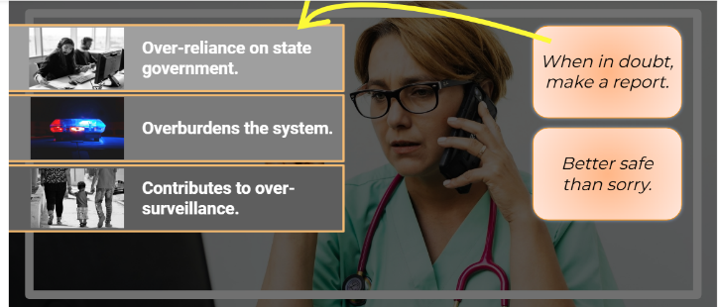

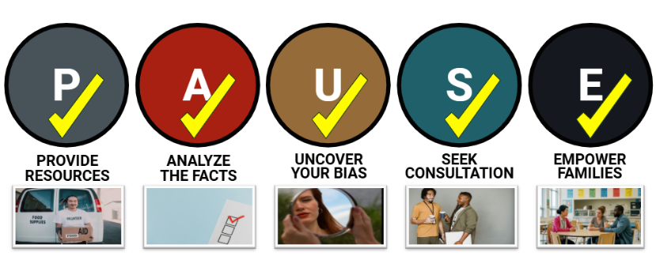

- A survey was provided in the chat for participants to offer additional feedback: Mandatory Reporting in Vermont - Community Feedback
- A small group was identified to further explore Title IV as it intersects with child welfare reports.

